Factsheet 4

How should co-design be implemented?

What is co-design?
When involving people with disability in engagement activities, consider people’s particular needs and support them so they can offer their best contributions.

Commit
Obtain commitment from the relevant senior executive for a genuine co-design process and establish clear commitment to co-design process within a department or organisation:
- Are we genuinely open to fully including people with disability in co-design?
- Can we be open to outcomes that may be different to what we have envisaged?

Communicate
Brief relevant areas of a department or organisation on the intent and process of the co-design process:
- Have we briefed everyone who will be involved in or impacted by the process?
- Have we invited the right people internally into the process?
- Have we circulated co-design principles to all those involved?

Levels of co-design
Co-design can happen across an organisation/system simultaneously on many different projects and initiatives. These opportunities can be broken into four levels:
- Individual
Examples include individualised support plans actively involving the person who requires assistance, their family/carers, service providers and other stakeholders.
- Service
Service level engagement with service-users (people with disability, their families, supporters) to redesign an existing service or program.
- Network
People co-design plans that that meet the needs of the relevant population or community, town or region. This may involve multiple funders, service providers and programs, a wide range of service users, including people with diverse disabilities, and other stakeholders.
- System
The greatest opportunity for major transformational change may be where the design process considers a whole of system level. This may involve multiple levels of government, numerous agencies, industry, organisations, communities, and individuals. This may result in the development of innovative solutions to issues, and reduction of siloed approaches.

Levels of engagement

INFORM
Goal: To provide people with disability with information to assist them in understanding issues, opportunities and solutions.
Level of influence: No ability to influence the decision.
Type of engagement:
- Fact sheets, websites, information sessions in accessible formats, platforms, or venues.
- Informing the community with balanced and objective information around an issue or situation.
- Sharing information about a government decision or direction in accessible formats.

CONSULT
Goal: To provide people with disability with information to assist them to help understand the issues, opportunities, solutions.
Level of influence: Low level of influence, usually participants are presented with an issue and proposed alternate/solution and asked for their reaction and comment.
Type of engagement:
- Public meetings, focus groups, surveys in accessible formats, platforms, or venues.
- Seeking comment on a proposal, action, or issue.
- Seeking feedback on a service or facility.

INVOLVE
Goal: Work with people with disability throughout a process to ensure concerns/opinions are included in the decision-making process and development of solutions.
Level of influence: Moderate. Stakeholder concerns and aspirations are directly reflected in the alternatives developed, and feedback is provided on stakeholder influence.
Type of engagement:
- Workshops, deliberative polling, and expert panels in accessible formats, platforms, or venues.
- Involving people with disability at various times throughout the planning cycle, for example, keeping them informed and enabling further comment.

CO-DESIGN (COLLABORATE)
Goal: Collaborating with people with disability and other relevant stakeholders in each aspect of the decision, including development of alternatives and the identification of the preferred solution.
Level of influence: Moderate to high. Stakeholders directly involved throughout the process, including in formulating solutions and their advice and recommendations incorporated into final decisions to the maximum extent possible.
Type of engagement:
- Steering groups, advisory committees
- Boards of management
- Expert working groups
- User testing
- Journey mapping
- Prototyping
At times, it may not be optimal or feasible to undertake co-design processes, such as when the disadvantages outweigh the benefits of utilising a co-design approach. While co-design may be used at a certain point/s in a process, it may not be feasible to utilise co-design at all stages of an engagement cycle.
It is important to label your engagement activity correctly. Ensure the integrity of true co-design is maintained. Sometimes a genuine intent is compromised when there is insufficient time or process available for true co-design. Sometimes a process is promoted as co-design but is really consultation. Be sure to optimise the engagement process for the best outcome but do not misrepresent the actual type of engagement that will be undertaken.
At its heart, co-design is about working together. It’s about recognising that when we address complex problems involving multiple actors across government, the private sector and the broader population, it is incredibly unlikely that any one person will have the answer.
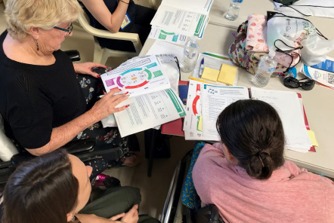
Image caption: A group of people sitting around a table reading booklets.

